How many radiographs are enough or required for a root canal treatment?

It was decreed by someone, long ago, that root canal treatment on single rooted teeth should be done with the aid of four radiographs only. That is what the third party insurers (medical aid) will cover. Why?
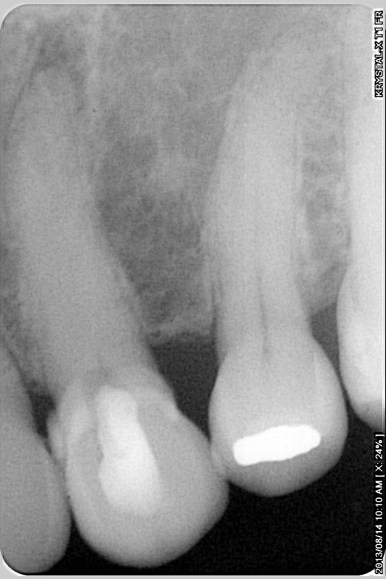
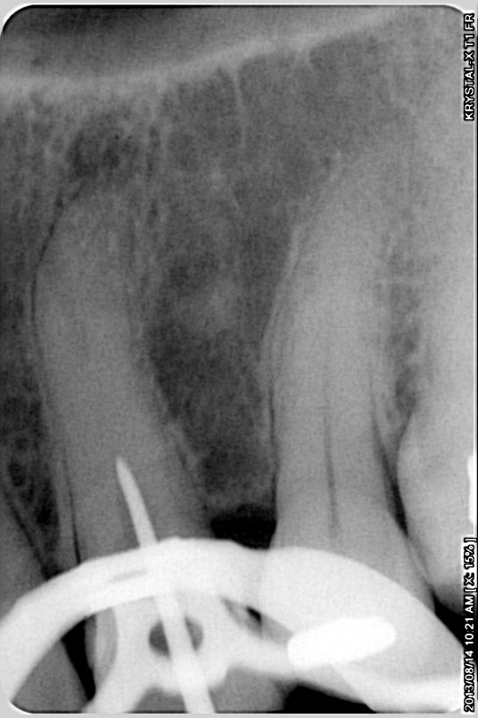
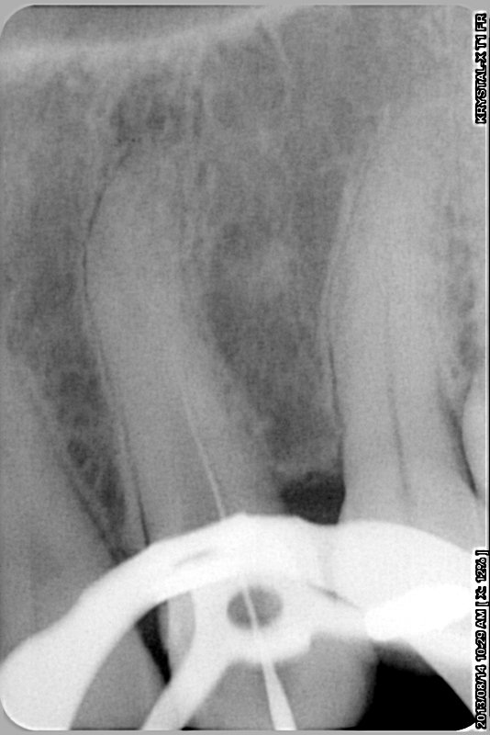
A patient was referred for root canal treatment on the upper left canine, the 23. The treating dentist could not locate the canal, due to calcification. A pre-operative radiograph was taken, Figure 1. This diagnostic radiograph confirms the absence of a clear, wide, open canal, a peri-apical radiolucency, curved root and the access cavity prepared by the referring dentist. It is imperative that all referred patients’s teeth be assessed by a radiograph taken by the endodontist before the latter even “touches” the tooth. Once the endodontist has started operating on a tooth, he or she has to accept full responsibility for treatment. Pre-existing conditions such as fractured instruments, perforations or other forms of iatrogenic treatment must be confirmed before the specialist commences treatment.
Figure 1
Figure 2
Figure 3
I initiated treatment and became aware of the extent of the calcifications. To confirm that I was instrumenting correctly, that I was on the right path, so to speak, I exposed another radiograph, with an explorer tip in the depth of my exploratory cavity, Figure 2, indeed confirming my estimation of the canal location.

Eventually, after a considerable effort a canal was located with an 06 size root canal file, Figure 3. The file tip is so fine that it is impossible to see it on this radiograph, but the feel of the instrument as well as the general direction of the file confirmed that the canal was indeed being followed.

More instrumentation followed, resulting in deeper penetration and another radiograph was exposed, Figure 4. At this time I became concerned about the eccentric location of the instrument inside the root. It was clear that the apical foramen had not been reached yet.

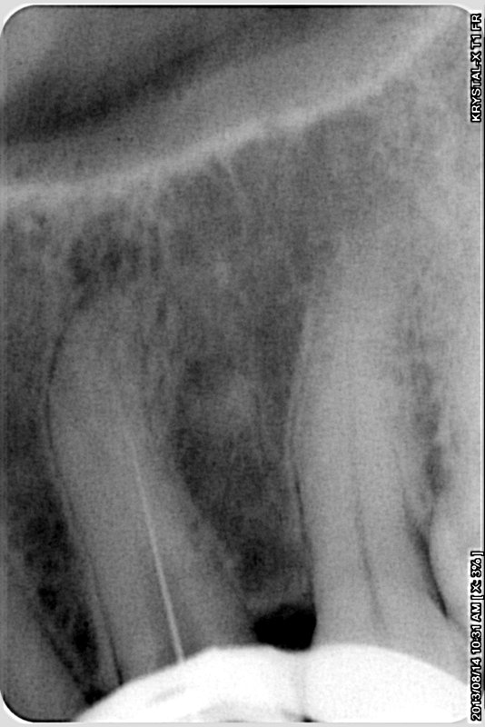
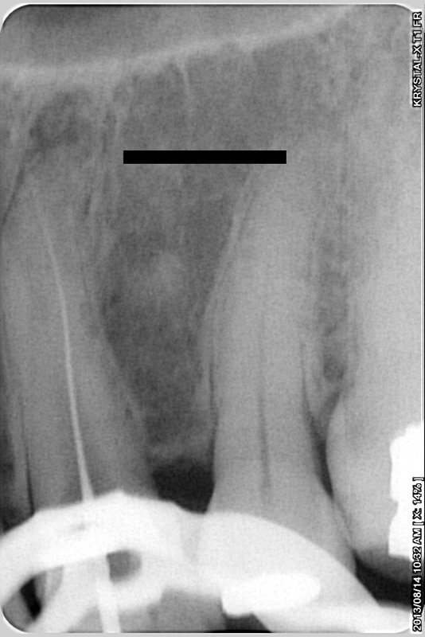
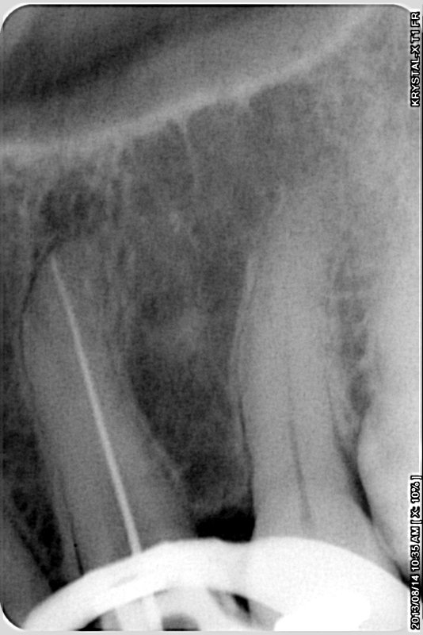
Further instrumentation followed until the instrument suddenly penetrated deeper, The larger instruments easily followed the pathway and a size 15 instrument was judged to be more or less at the desired working length. Because of the larger size of the file it was more clearly visible on the next radiograph, Figure 5.
Figure 4
Figure 5
Figure 6

Finally, I managed to get a size 20 instrument to what I estimated my working length and another radiograph more or less confirmed this, Figure 6. One thing still concerns me and that is the position of instrument’s apical tip. It is on a straight line, from the access cavity, despite the tooth’s natural curve. One would most often expect the apical foramen to be at the radiological apex, around the curve. Only time will tell whether I had reached the real foramen or whether I had created my own foramen, in other words whether I had transported the apex.

Discussion

I found it necessary to use six radiographs to get this far. During the obturation procedure, scheduled for a next appointment, I will expose at least two more, a trial fit of the master GP cone and a post-operative radiograph. Should there be complications, I will expose more, as many as it takes, to get a “perfect” result.

The questions are these, “How many are enough?”
“Which of these radiographs were unnecessary, if any?”
“Can this case be done with only three or four radiographs?”
“Should the patient be charged for all these radiographs?”

I have my own views on the matter, but one thing is very clear in my mind- nobody has the right to tell me that I may only use three or four radiographs, including the diagnostic radiograph, to do a root canal treatment. I will use as many as I deem necessary.

